# Visual Studio Code Tutorial

1. Download and install Visual Studio Code <https://code.visualstudio.com/>
2. Download and install NodeJS <https://nodejs.org/>
3. Create a folder e.g. C:\myapp
4. Start a console / terminal and navigate to your folder  
   For Windows:
   1. Press Win+R
   2. Enter *cmd* and press enter  
      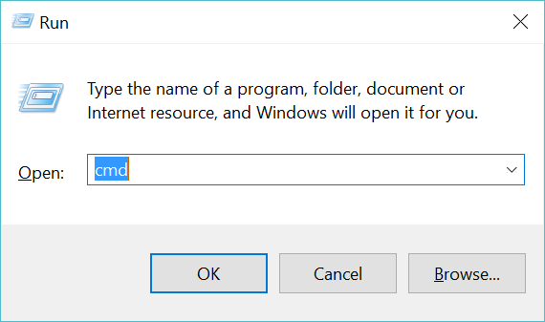
   3. Type in cd *C:\myapp* and press enter
5. Run the command *npm init*
6. Start visual studio code (can be done by calling *code .*)
7. Click on extensions in the left and search for and install Windows IoT Core Extension, click on the reload button afterwards to restart visual studio code  
   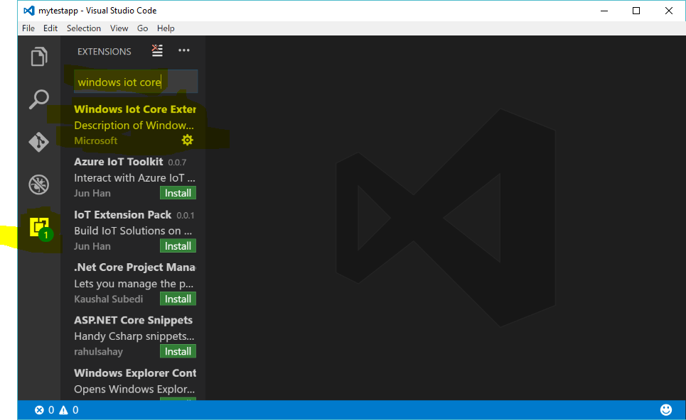
8. Press F1 and type in *iot init* and press enter  
   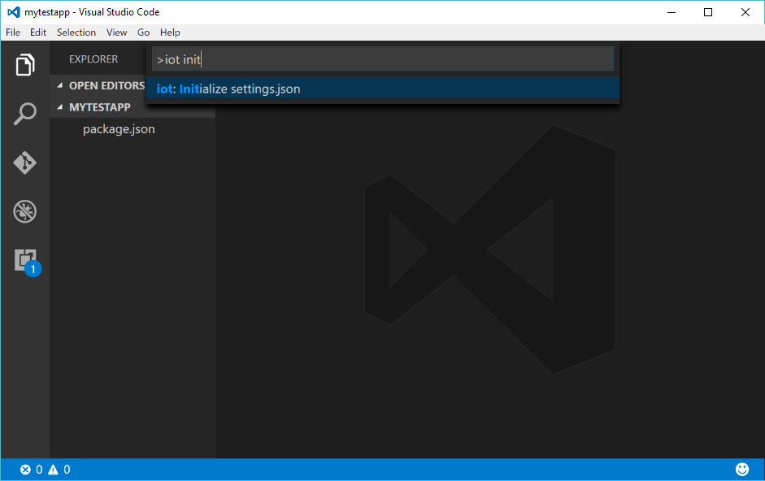  
   Note: These settings are saved in *myapp/.vscode/settings.json*. You can either change these settings in this file or you can delete it and rerun the initialize command.
9. Create a new filed called index.js  
   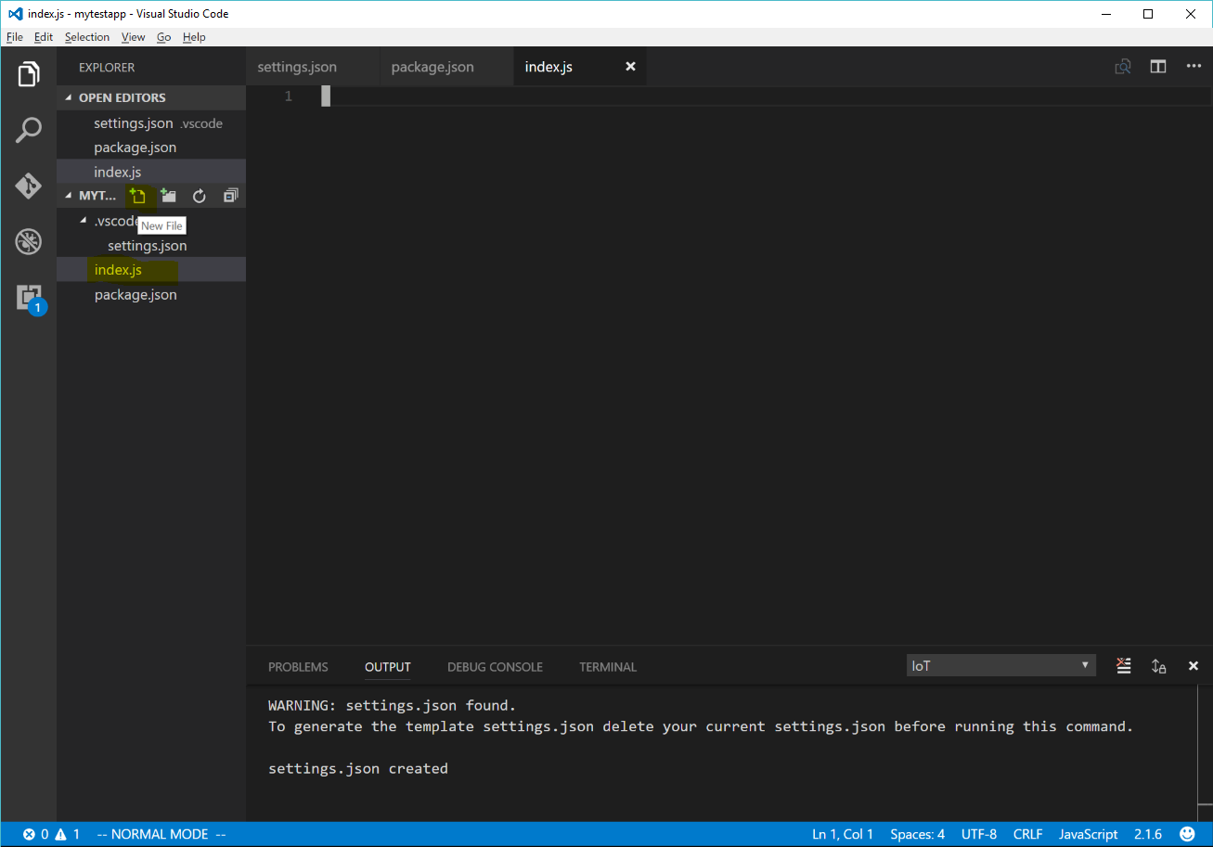
10. Enter the following code  
    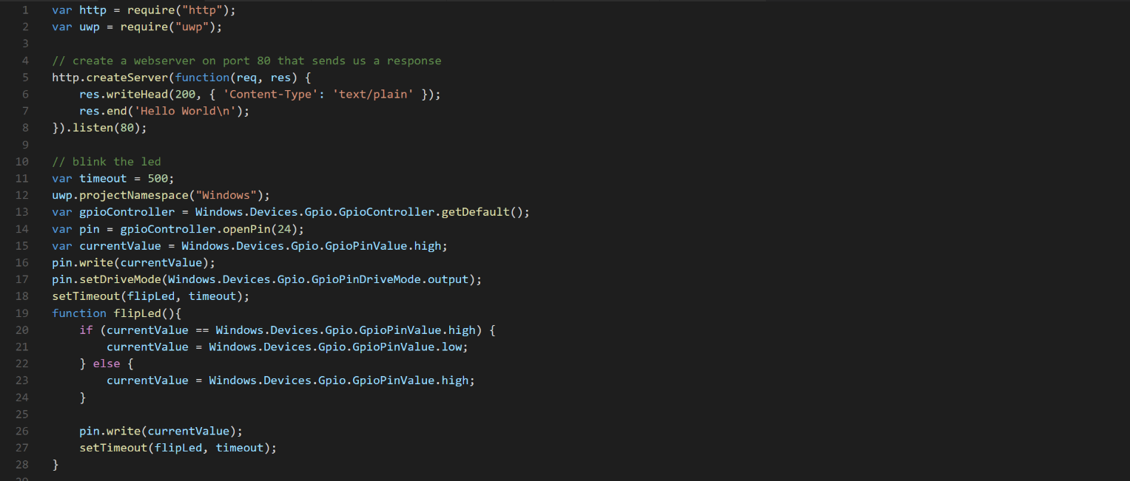
11. Press F1 and type in *iot start*, then press enter:  
    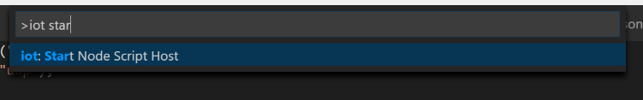

Note: If you make changes you may have to first update your files on the pi before starting the node script host. To do this press F1 and type *update* and then press enter:  
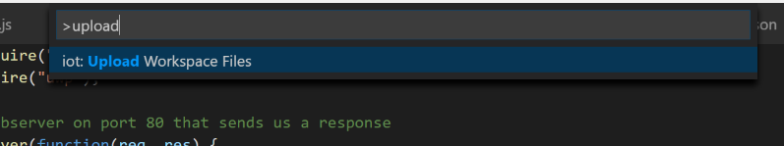

1. The LED should start blinking, you can also visit the webserver using the address <http://myraspberrypi/>, replacing *myraspberrypi* with your devices IP address.
2. Add the following code to subscribe to the buttons events:

